<<Insert YOUR COMPANY LOGO HERE>>

**Managing a   
Cost Savings Portfolio**

KPI FIRE USER GUIDELINES

*This purpose of this document is to describe how* <<Our Organization>> *will utilize KPI Fire to achieve our Cost Savings goal for* <<year>> *of* <<Savings_Target_In_Dollars>>

***Primary Purpose of KPI Fire Software:***

*-Be the source of truth for Continuous Improvement Cost Savings projects*

*-Use for reporting progress: Budget vs Target vs Actual*

*-Organize Project management activities*

<Sections in blue text should be replaced with company specific information before use>

Keith Norris

03.15.2024

## 1 Introduction

### **What is a Cost Savings Project?**

A cost savings project is a type of project that is aimed at identifying and implementing changes to reduce the costs of a particular process, product, or service. The primary goal of a cost savings project is to identify areas of waste or inefficiency and to implement changes that will result in significant cost savings for the organization.

## 2 Language & Terminology

|  |  |  |
| --- | --- | --- |
| KPI Fire Term | Meaning | <<Company>> Equivalent Term |
| Department | A term used to describe a business unit, function, or division. Every Project, Goal, Metric in KPI Fire will be assigned to a Department. |  |
|  |  |  |
| Project | A distinct effort or initiative designed to improve our business, or generate savings. Projects have a charter, a team, tasks assigned to team members, and ideally should result in a Financial Project Benefit. |  |
| Project Benefit Account | Projects will have Benefits(+) or Costs(-) |  |
| Metric |  |  |
| Tasks & Task Groups | Projects contain task groups and Tasks. Tasks are individual units of work to complete. | Milestone, action item |

## 3 Departments & Project Benefit Accounts

Projects in KPI Fire will be assigned to Departments and will be designed to achieve financial benefits.

Each Department will be asked to identify projects that can result in financial benefits that can improve the business.

Annual Budget is the term used by KPI Fire to identify the total targeted amount of savings desired for each business unit & the corresponding benefit account.

|  |  |  |
| --- | --- | --- |
| Department | Total Financial Benefit |  |
| Company | $1,000,000 |  |
| Department A | $700,000 |  |
| Department B | $300,000 |  |
|  |  |  |
|  |  |  |
|  |  |  |

<Admin Setup: Configure the Departments and benefit accounts and update this training document. >

## 3. Solicit Ideas (Ideas become Projects)

Ideas can be captured in 3 ways

* Direct Input in KPI Fire web application (Login required)
* KPI Fire Mobile application (login required)
  + https://www.kpifire.com/blog/mobile-app/
* External Webform or QR Code on a Poster. (no login required)
  + <<Admin Setup Required>

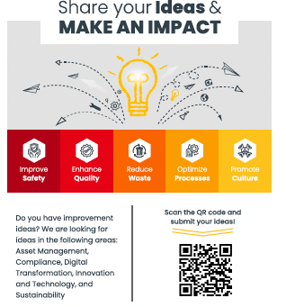

## 4. Prioritize Ideas (Effort vs Impact)

New Ideas will show up in the Idea Funnel tab.

**To Prioritized Ideas** : Idea status & priority are empty   
**Prioritized Ideas** : Idea status & priority has a value   
**Activated Ideas (Projects)** : Active status

Notifications can be configured in the Notifications area for each user.

## 4 Projects

Projects are how “the work to be done” is organized in KPI Fire. A Project is a chunk of work that is owned by a single Project Leader. In KPI Fire, Projects consist of a charter, tasks, task groups, and project benefits. Projects can be linked to Metrics and Goals.

Workflow is the term used for a project template. Workflows can be used to create standardized approaches to solving problems or accomplishing projects.

Project Video: <https://youtu.be/w6tqJUroe4U>

**4.1 When to Create a Project in KPI Fire**

Any project that meets the following criteria should be added to KPI Fire: <<INSERT Criteria>>

• Is a significant component of goal that is tracked in KPI Fire:

• Continuous Improvement Projects

• Projects intended to get a goal back on track

When do we combine projects?

When do we split projects?

When should you NOT create a project?

Use sigma tracker for:

Use lean tracker for:

**4.2 Project Naming**

Use a descriptive name that can help avoid redundancy. If the project is likely to happen again, use a name that makes it easy to identify such as adding the month & year to the project name.

|  |  |
| --- | --- |
| Bad Project Name | Good Project Name |
| Carousel | Vertical Carousel & Software implementation MN |
| <<Add more examples here>> |  |

**4.3 Workflows**

Workflows are templates that control the project Charter fields, task groups, and tasks.

Custom workflows can be created when needed by Admin users. If you would like to have a customization made to a workflow contact: <<INSERT ADMIN NAME>>

We will use the following workflows:

|  |  |  |
| --- | --- | --- |
|  | Workflow | |
| Name | When to use it | Who will use it |
| PDCA | TBD | TBD |
| DMAIC | For 6 Sigma projects | TBD |
| A3 | TBD | TBD |
| Savings/Approvals | TBD | TBD |
| 8D | TBD | TBD |

2 Types of Kaizen:

Structured Kaizen: more than a day use:

Daily Kaizen: Less than a Day (Quick & Easy: don’t require documentation)

1 Project Per site/ Per year for daily Kaizen.

Track your activity:

|  |  |  |  |  |
| --- | --- | --- | --- | --- |
|  | Small Projects  Daily Kaizen | | Large Projects  Structured Kaizen | |
| Department | Criteria | Workflow | Criteria | Workflow |
| Operational Excellence |  | Start from Scratch | TBD | DMAIC |
| Engineering | TBD | TBD | TBD | TBD |
| Lean/Sigma | TBD | TBD | TBD | DMAIC |
| Quality | TBD | TBD | TBD | TBD |
| Automation | TBD | TBD | TBD | TBD |
| Plants | Use 1 Project Named Daily Kaizen+ Site Name | Use 1 Project Named Daily Kaizen+ Site Name | TBD | TBD |

**4.4 Project Charter**

All projects require the completion of a project charter and respective approval. The Charter should be completed as a project is initiated & should be based on discussions between the Manager (Sponsor) and the Project Leader.

Charters should include: What specific things do you want people to complete?

|  |  |  |
| --- | --- | --- |
| Field Name | Description of Use | Required |
| Problem/Opportunity Statement | A brief statement of the problem or opportunity. Example: <<list example here>> | Y |
| Goal Statement | The overall objective of this project | Y |
| Project Scope | What is specifically included, what is specifically excluded from the scope of this project. | Y |
| Planned Start Date | The date the project is expected to start | Y |
| Planned Completion Date | The date the project is expected to finish | Y |
| Actual Start Date | The date the project is activated (can be manually set) |  |
| Actual End Date | The date the project is closed. This date will show as expected completion date while a project is active and will be based on the longest outstanding task in the active project. |  |
| Before/After Photos | For process improvement work, take a picture of the before and after. | N |
| Linked Goals | Link the project to strategic goals created in KPI Fire. | N |
| Linked Metrics | Link the project to key performance indicators that will be moved by the project. | N |

**4.6 Track Savings as Project Benefits**

Track savings as either a one-time saving or once per month for 12 months.

What Project Benefits will we use:

Total: This value will auto-sum

Hard Savings: Update this 1x month for 12 months

Soft Savings: (not used)

Project Costs: (one time)

How to set Targets:

Where will we Track our Savings? Most savings will be rolled up from the individual sites. Some projects will

Project Benefits Blog: <https://www.kpifire.com/product-updates/total-project-benefit/>

**6 Users**

**6.1 User Roles**

Most users will be either Project Leaders or Team Members. For large Projects, the Project Sponsor should be the functional member of the Executive Leadership Team; for smaller Projects the respective Department Leader. In addition, one or more Project Champions can be selected for each Project. A Project Champion can be any person that holds a specific interest in the successful implementation of the project and can usually support the project’s execution (i.e. through resources, influence, knowledge).

For each Function/Region, we have nominated a Subject Matter Expert, who can assist with questions relating to the use of KPIFire.

|  |  |  |
| --- | --- | --- |
|  | User License Types | |
| Department | Description of Rights | Who has this |
| Admin License | Access to all areas of the application. Configures departments. | <<User Name>> |
| Strategy License | Can create goals & metrics, and lead projects | <<User Name>> |
| Project License | Can lead projects, can see goals or metrics IF linked to their project. (No goal or metric access in main menu) | <<User Name>> |
| Team Member | Can be added as a team member to projects. (No goal or metric access in main menu) | <<User Name>> |
| Idea License | Can only submit ideas | <<User Name>> |

License Types Blog: <https://kpifire.com/kpi-blog/kpi-fire-user-license-types/>

User Roles Blog: <https://www.kpifire.com/blog/project-user-roles/>

**6.2 User Rights**

Users that are given a Strategy License will be allowed to see and create projects, goals and metrics. Unless the visibility of a project, metric, or goal was set to a specific Department only, all Strategy License holders will be able to see all projects, metrics, and goals.

Project Team licenses are available for users who are primarily team members and do not require full access.

There will be additional users with an Admin License to assist in the initial configuration of company settings and implementation of KPI Fire. Once the roll-out is complete, Admin Licenses will be limited to 2-3 users who will support further set-up changes.

Personal or sensitive projects and goals can be set to “Visible to Just Me” which will limit the visibility to the creator and admins.

**6.3 Adding Users**

If you are working on projects with people who are not in KPI Fire, they can still be added to the team. Users may be added only by Admin users. If you need to add a user please send your request to: <<User Name @ user@email.com>>

**7 Departments**

Every user is bound to a department, which should match their current reporting line.

Departments and a user’s allocation to a department must be changed by Admin. Departments are used as a filter criterion for goals, metrics, and projects (i.e. show all R&D projects). The association to a specific department does not limit a user to work on projects that belong to a different department.

The current department ‘tree’ shows <<Company Name>> at the top level and all functions underneath. Within each function, there can be sub department, i.e. Operations Plant.

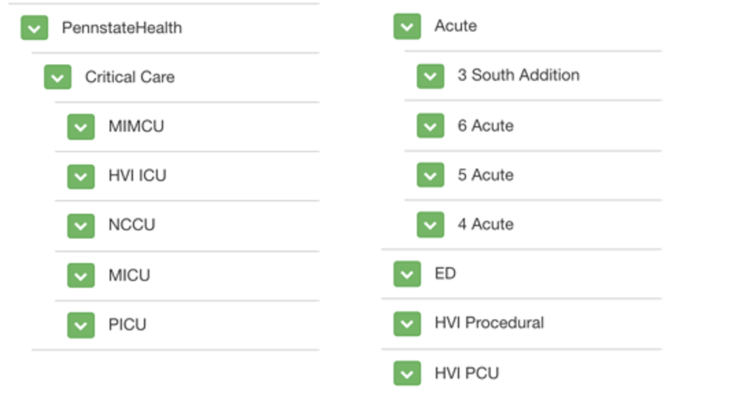

**8 Workflows**

As well-defined projects deliver better results than those with unspecific descriptions, large projects will follow the Six Sigma methodology of Define, Measure, Analyze, Improve, Control (DMAIC). Each of these five project phases is represented by a specific section within each workflow template. Each function has a defined workflow template, i.e DMAIC Operations, DMAIC R&D IM and DMAIC General.

Smaller projects may be managed using one of the above workflows or a simplified workflow called Quick Wins.

**9 Reporting**

Within the software, there are several options to report progress as desired or requested, depending on the project size and importance. The Project Leader is responsible for the Project Progress as well as updates on roadblocks, scope, target or deliverables changes.

**10 Huddleboards**

For every project there are several project views and display options (i.e. the Project Benefit charts) to keep Team Members informed.

Huddleboards can be created as a place (physical or virtual) where a team can meet and review priorities and make plans.

It is recommended that Project Team Members regularly check on the progress of their projects.

Huddleboards Blog: <https://www.kpifire.com/blog/huddle-board-examples/>

**11 Rituals**

The success of this initiative relies on each individual’s commitment to adopt certain behaviors including the following:

|  |  |
| --- | --- |
| Rituals | Description |
| Daily Email or Task List Check | Check your email each day for notifications that may be sent indicating action required in KPI Fire. |
| Weekly Project Review | Review each of your projects on a weekly basis. |
| Idea Capture & Idea Review | Capture ideas in real time & schedule a regular meeting (weekly or monthly) to review them & activate the right ones. |
| Project Creation | Enter new projects in KPI Fire, complete the project charter as agreed and choose the appropriate workflow. |
| Monthly Metric Update | For users responsible for updating metrics, record your metrics on a monthly basis. |
| Monthly Goal Review | Review the Goals linked to your projects and their progress on a monthly basis. |
| Annual Goal Planning | Update Goals on an annual basis. |

Rituals Blog: <https://www.kpifire.com/blog/strategy-execution/>