## Overview

What is the Problem KPI Fire Solves?

Many organizations use suboptimal tools and methodology to deploy strategic goals and metrics and track performance to those metrics. This is often difficult, time consuming, and does not provide the real-time visibility and accountability needed.

How KPI Fire can Help

KPI Fire Strategy Execution Software will equip you with the visual tools, metrics, and systems to communicate goals and metrics, measure performance, manage risk, and execute strategy. With KPI Fire Strategy Execution Software, it’s never been easier to align strategy, drive execution, and engage your people.

* Save Time & Simplify Strategic Business Reviews:  Stop wasting weeks preparing for strategic business reviews that don’t justify the time they take to prepare.
* Recognize Success & Evaluate KPIs Objectively:  Visually evaluate strategy success with objective color-coded metrics.
* Avoid Failure & Initiate Corrective Actions Early:  Use standardized templates for corrective actions and business cases.
* Improve accountability to project schedules and results
* Standardize project execution workflows: A3, DMAIC, PDCA, PMBOK, etc.
* Provide an Idea Engine to capture and prioritize projects

A Complete Strategy Deployment System

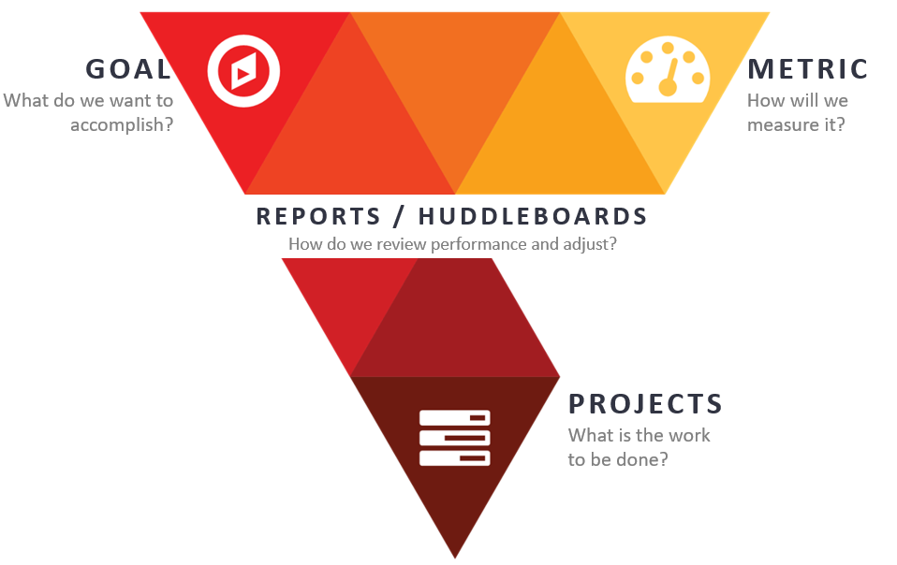Introducing the four key elements of KPI Fire, perfectly aligned to create a culture of performance improvement.

Strategy Deployment

## The Five Elements of KPI Fire for Executing Your Strategy

1. Effectively Communicate your Strategic Initiatives and Align Projects with your Strategy

Most organizations spend excessive time planning, but fail to [communicate the plans](https://hbr.org/2011/08/eight-ways-to-energize-your-te) in a way that allows the organization to stay focused and execute. KPI Fire Strategy Execution Software serves as your organization’s single source of truth for the strategic plan.

Many employees report “[unclear goals” as the #1 source of stress in their lives.](https://www.kpifire.com/strategic-planning/the-42-problem-unclear-goals-are-the-top-source-of-stress-in-peoples-work-lives/) If your strategic plan is still living in a document on your bookshelf, or if it’s lost in an email from six months ago, you are part of the problem.

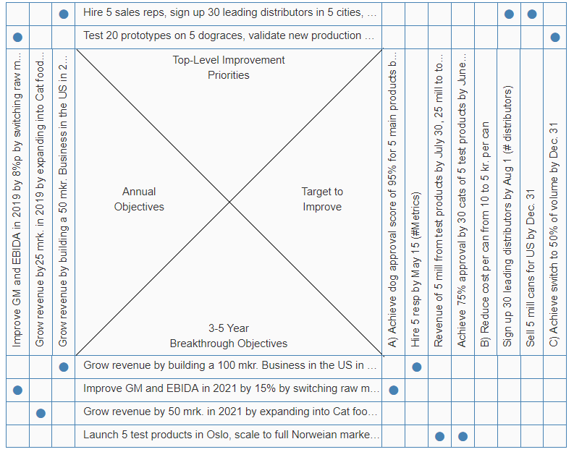KPI Fire contains multiple views for sharing your strategic plan, objectives, and goals. Everyone can see how their work is contributing to the organization’s success.

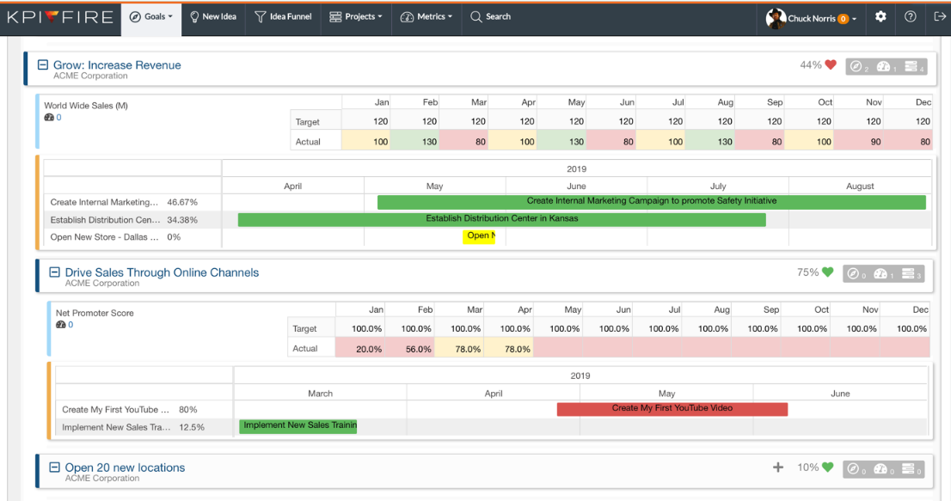 Your leadership team’s secret weapon for communicating and reviewing annual objectives.

1. Simplify Business Reviews. Visualizing Performance Data with KPI Dashboards

Typical monthly or quarterly business reviews can take more time than most businesses are proud of. With KPI Fire you can simplify & standardize the format for your Business Reviews and reduces wasted effort on PowerPoint slides that don’t add real value. You can get more frequent reviews and get them done in less time and with less effort than before.

KPI Fire provides real time visibility to your KPIs (key performance indicators), Goals. Projects and tasks.

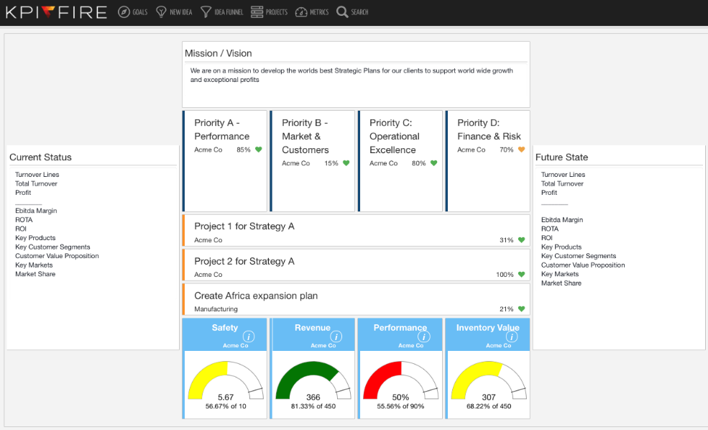Add weights to Goals and Metrics to track Balanced ScoreCard performance.

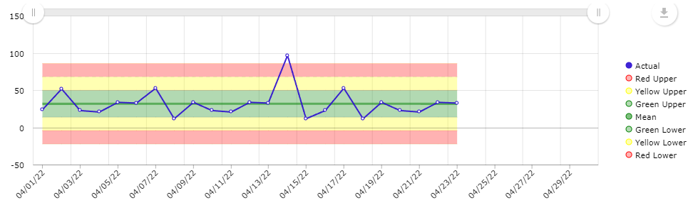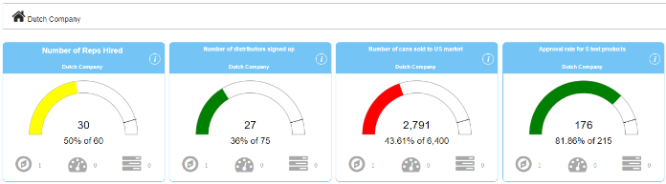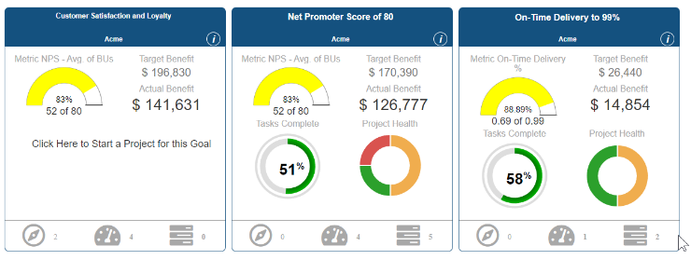

1. Execute Work with Project Management Tools and Visibility to Status

As you deploy your strategy It’s important to understand the status of projects and other work tasks that will yield the results set forth in the plan.

KPI Fire provides a simple red, yellow, or green status for project work as well as KPIs so you always know where your teams are succeeding and where leadership may need to help. Improving accountability while increasing employee engagement.

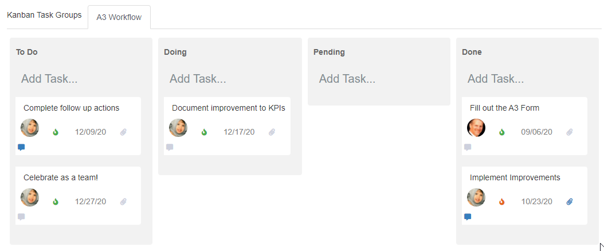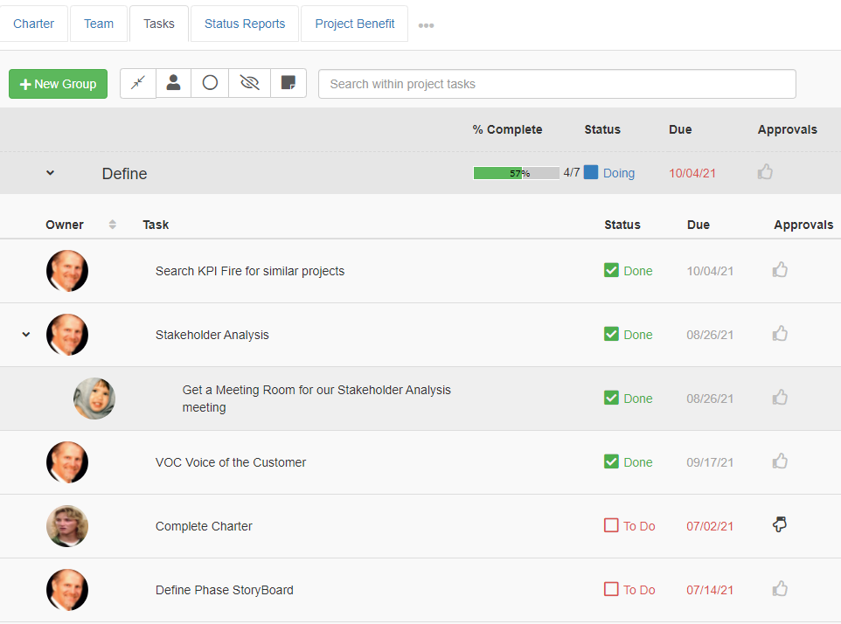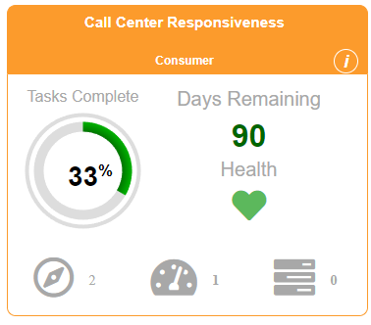KPI Fires’ complete project management system is easy to use yet powerful enough to handle all your important work. From drag and drop Gantt charts to customizable workflow templates, each aspect of the system can be adapted to your unique business needs.

Project Dashboards – Quickly see which projects and teams are healthy and on track.

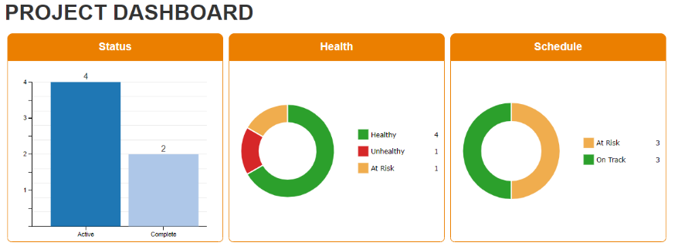

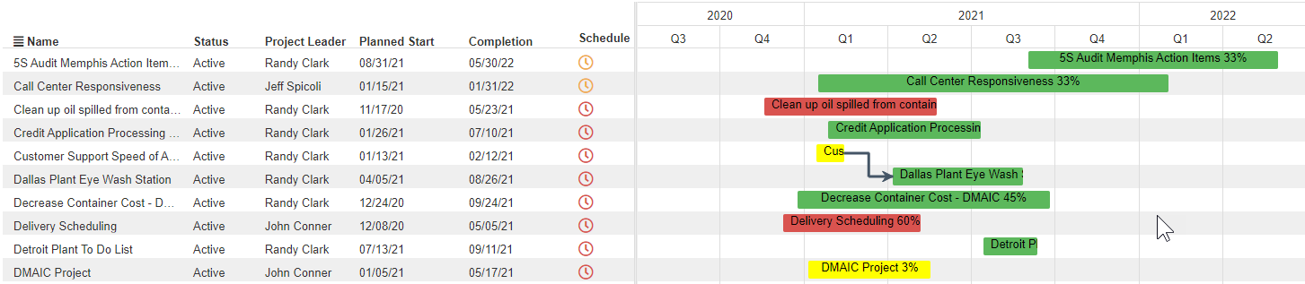

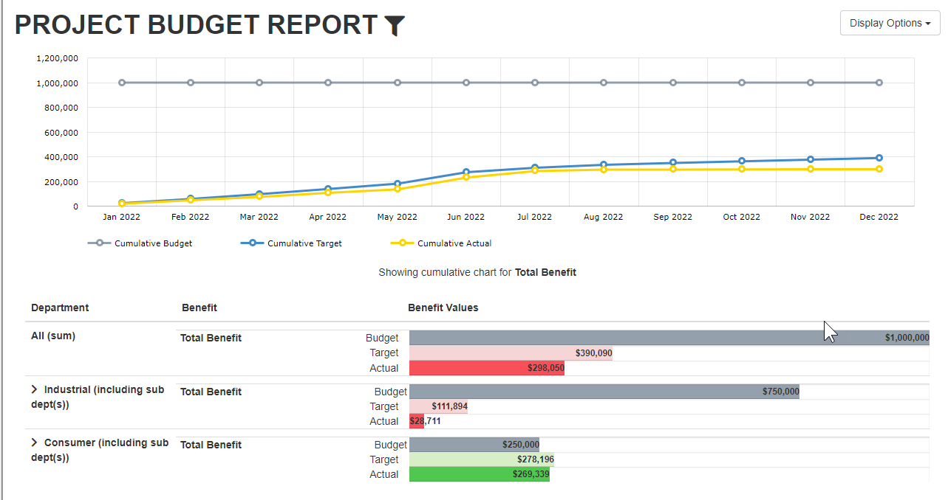Manage Project Costs and Benefits – dashboards that show the value and cost of projects vs plan.

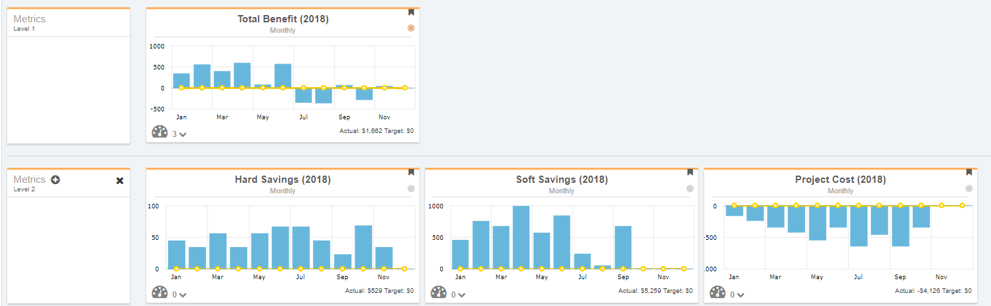

1. Capturing Ideas and Engaging Your Team

KPI Fire makes it easy to engage your employees, capture their best ideas, and turn those ideas into projects that get results. Idea entry can be done on the web or via the phone App. The Idea Funnel helps teams sort their suggestions and select projects that are aligned with their strategic goals.

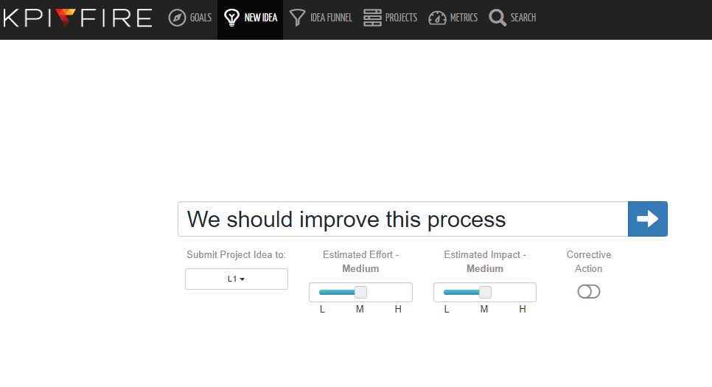

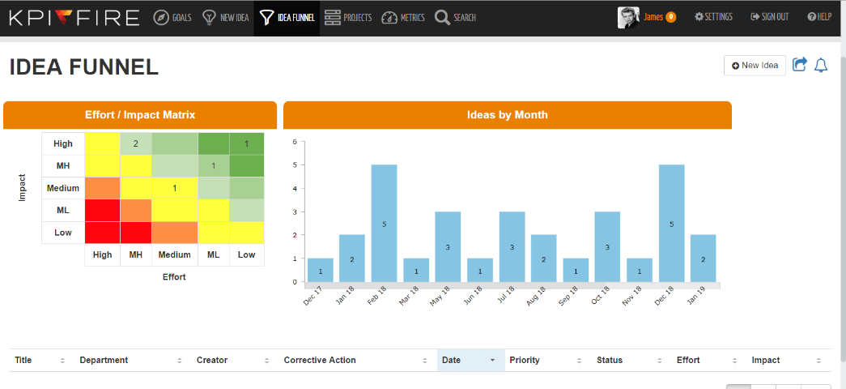The Idea Engine – A super-fast way to capture every team member’s ideas, Phone App Included.

Idea Funnel – Prioritize ideas by effort and impact. Track your progress creating and implementing ideas.

1. Overcome Common Problem Areas

KPI Fire provides solutions to the most common problems in executing strategy.

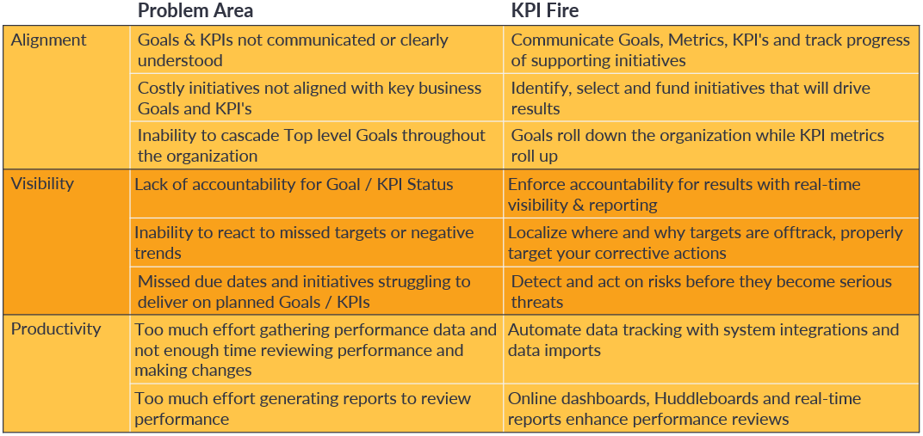

## About KPI Fire & COMPLETExRM

KPI Fire is part of a suite of software owned by COMPLETExRM. Our team has been helping companies and individuals reach their goals for over 15 years. We are a privately held company based in Salt Lake City, Utah operating four software platforms, KPI Fire (corporate strategy and continuous improvement), PlanPlus Online (sales and marketing), Pocket Informant (personal productivity) and Standup Alice (automated stand-up). We have thousands of satisfied clients around the world both big (20,000+ employees) and small (50 employees) and from all industries including manufacturing, healthcare, mining, finance, hospitality, and more. Our software solutions are delivered in over 14 languages.

## Summary

KPI Fire will help you grow a culture of strategy execution:

* Save Time & Simplify Strategic Business Reviews:  Stop wasting weeks preparing for strategic business reviews that don’t justify the time they take to prepare.
* Recognize Success & Evaluate KPIs Objectively:  Visually evaluate strategy success with objective color-coded metrics.
* Avoid Failure & Initiate Corrective Actions Early:  Use standardized templates for corrective actions and business cases.
* Improve accountability to project schedules and results
* Standardize project execution workflows: A3, DMAIC, PDCA, PMBOK, etc.
* Provide an Idea Engine to capture and prioritize projects

KPI Fire is uniquely positioned to support you with the tools leaders need now on a platform that scales with you. We are excited to partner with you in reaching your goals!

|  |  |  |  |
| --- | --- | --- | --- |
| A person smiling at the camera  Description automatically generated Nihar Nana Customer Success Manager  801-845-3125  [nihar.naha@kpifire.com](mailto:nihar.naha@kpifire.com) |  | Randy Clark VP Sales KPI Fire 801-456-8172  [randy.clark@kpifire.com](mailto:randy.clark@kpifire.com) | Keith Norris CEO Complete XRM 801-231-5657 keith.norris@kpifire.com |